**SkyChat**

SkyChat is an automated chat system designed and developed at the SkyBits R&D lab and is implemented in a variety of industries. It is easy to interact with, using technology users are comfortable within their own natural language. The system can be deployed on premise or on cloud as per the customer’s needs. The system is ideal for being deployed on various company websites to handle customer queries on a 24/7 basis. The product proactively interacts with the user on the other end, thus increasing customer engagement. It can handle eCommerce transactions because it is a smart NLP. Overall, “SkyChat” saves a lot on the cost side of our customers.

Real Language

Better Interaction

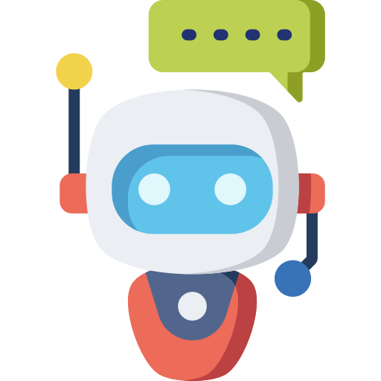

Channel Agnostic

Simple Interface

Greater Efficiency

Instant Response

Sales Booster

**Medi ChatBot - MEDER**

“Meder” is a healthcare chatbot which help patients to solve their medical issues instantly. From requesting an appointment to ordering medicine, Meder is capable of all. This chatbot for healthcare will not only help patients but also help doctors and other medical staffs by reducing their burden. Meder can help the patients and doctors locate previous prescription and medical files of an existing customer, order the medicines directly, look at the wait time estimation in hospitals etc. Meder is the one stop chat solutions that will constantly serve the patients with complete satisfaction.

**Features:**

* Request an appointment;
* Solve the daily life medical problems like fever, stomachache etc.
* Take order of medicines;
* Answer FAQs.

**Technology and languages Used for backend**

* RASA-Core and RASA-NLU to train the model and maintain the conversational flow
* Tensorflow module to extract data from files
* MySQL connection and MySQL queries
* Python to trigger the custom actions
* Django to upload in the django server

**Technology and languages Used for frontend**

* HTML
* CSS

**Future Features**

* **Special option for women relating to their menstrual health and any sexual issues ;**
* **Diet planner ;**
* **Option for mental health issues .**
* **Queue/Waiting Time Estimation .**

**Banking ChatBot - ERA**

Era is an automated chat application used to Conduct an Online Chat Conversation via text For a Banking System . Era is programmed to handle all types of Queries and it also improves efficiency and reduce the workload. Banking chatbot is one of the best use cases for Chatbots right now. Era is a customer support bot that can reduce the load of enquiries on the customer service helpline. Features like Nearest ATM Locator, Opening of an account, Enquiry about Loan etc., wait time estimation in a particular bank branch are a few Features that make it unique. The chat bot has a special feature where it understand untrained question and send it to the right department for a better in person response.

**Features:**

* Opening Account ;
* Loan Enquiry ;
* Call Back Requests ;
* FAQS ;
* It Provides 24/7 Instant online support to customers.



Customers

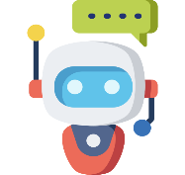

Answer

Intent Classification Algorithm

Generic/personalized questions

Ticket raised and estimated time to resolve matter sent to customer

Any Type of non-official Queries



SkyBits Complaint classification and management system

**Technology and languages Used for backend**

* RASA-Core and RASA-NLU to train the model and maintain the conversational flow
* Tensorflow module to extract data from files
* MySQL connection and MySQL queries
* Python to trigger the custom actions
* Django to upload in the django server

**Technology and languages Used for frontend**

* HTML
* CSS

.

**Future Features**

* Nearest ATM Locator
* Queue/Waiting Time Estimation

**HR ChatBot - NEWTON**

On average, an HR manager receives about 300–400 queries a day about leave requests, employee dashboard update status, feedback status, meeting scheduling etc. and most of the work is repetitive responding to same requests over and over again. What if the employees never need to bother HR with these queries? What if they had the independence to do routine tasks by themselves apart from a quantum increase in efficiency? This could significantly improve overall satisfaction across the organization leaving HR free to concentrate on personal interactions on important issues that need to be tackled at a person to person level. Now, empower every employee with an AI assistant available 24/7 to address all needs, execute simple or complex tasks using an on-premise simple conversational UI presenting , NEWTON .

With NEWTON , Adrenalin endeavours to create a game-changer that will enrich user experience with truly transformative Digital HR.

Leveraging the true power and potential of AI, NEWTON is remarkable in its ability to grow and get smarter the more you interact.

**Features:**

* Leave details across the current year
* Leave Application
* Notification
* FAQs including holidays list, leave types etc
* Read managers review
* Understand the KPI’s assigned
* Understand ones appraisal report
* Anonymous complaint system

**Technology and languages Used for backend**

* RASA-Core and RASA-NLU to train the model and maintain the conversational flow
* Tensorflow module to extract data from files
* MySQL connection and MySQL queries
* Python to trigger the custom actions
* Django to upload in the django server

**Technology and languages Used for frontend**

* HTML
* CSS

**Future Features**

* Scheduling meeting request
* Employee’s feedback and solution
* Update employee dashboard request along with update status within 24 hours